A

## MINI PROJECT REPORT

On

## Real-Time Eye-Controlled Mouse with Instant Brightness Maximization

Submitted in partial fulfilment of the academic requirements For the award of the degree of

### BACHELOR OF TECHNOLOGY

In

ARTIFICIAL INTELLIGENCE AND MACHINE LEARNING

By

P. Indra Sena Reddy 21B61A66A7

S. Naga Vaishnavi 21B61A66B3

M. Mohan Abhijeeth 21B61A6681

M. Ram Saiesh 21B61A6677

**Under the Guidance of**

Mrs. N. Kiranmai (Associate Professor)

**NALLA MALLA REDDY ENGINEERING COLLEGE AUTONOMOUS INSTITUTION**

Accredited by NAAC with “A” grade, NBA Accredited B.Tech. Programs **Divyanagar, Medchal – Malkajgiri (Dt), Ghatkesar(M), Narapally – 500088**

**2023 – 2024**



**Nalla Malla Reddy Engineering College**

Divya Nagar, Kachivanisingaram Post Ghatkesar, Medchal, Dist. 500088

Phones: 08415-256001.02.03. Fax: 08415-256000

Email: [info@nmrec.edu.in](mailto:info@nmrec.edu.in) Website: [www.nmrec.edu.in](http://www.nmrec.edu.in)

# **CERTIFICATE**

This is to certify that the mini project entitled “**Real-Time Eye-Controlled Mouse with Instant Brightness Maximization**” is being submitted by **P. Indra Sena Reddy** (21B61A66A7), **S. Naga Vaishnavi** (21B61A66B3), **M. Mohan Abhijeeth**(21B61A6681),

**M. Ram Saiesh**(21B61A6677) in partial fulfilment of the academic requirements for the award of degree of **Bachelor of Technology** in **ARTIFICIAL INTELLIGENCE AND MACHINE LEARNING** in NALLA MALLA REDDY ENGINEERING COLLEGE, Autonomous Institution, JNTU – HYDERABAD during the academic year 2023 – 2024.

**Internal Guide Project Coordinator Head of the Department**

**Mrs. N. Kiranmai Dr. B. Bal Narsaiah Dr. Sunil Tekale**

Associate Professor Associate Professor Professor

Department of AIML Department of AIML Department of AIML

**EXTERNAL EXAMINER**

# **DECLARATION**

We hereby declare that the project report entitled **“Real-Time Eye-Controlled Mouse with Instant Brightness Maximization”** is the bona-fide work done and submitted by us under the guidance of **Mrs. N. KIRANMAI**, in partial fulfilment of the requirements for the degree of **Bachelor of Technology** in **Artificial Intelligence and Machine Learning** to the Department of Artificial Intelligence and Machine Learning, **Nalla Malla Reddy Engineering College**, Divya Nagar, Medchal-Malkajgiri Dist.

Further we declare that the report has not been submitted by anyone to any other institute or university for the award of any other degree.

P. INDRA SENA REDDY (21B61A66A7)

S. NAGA VAISHNAVI (21B61A66B3)

M. MOHAN ABHIJEETH (21B61A6681)

M.RAM SAIESH (21B61A6677)

PLACE: HYDERABAD

DATE:

**ACKNOWLEDGEMENT**

The completion of the project gives us an opportunity to convey our gratitude to all those who helped us to reach a stage where we have the confidence to launch our career in the competitive world.

We express our sincere thanks to **Dr. M. N. V. Ramesh**, Principal, Nalla Malla Reddy Engineering College, Divya Nagar, for providing all necessary facilities to complete our project.

We express our sincere gratitude to **Dr. Sunil Tekale**, Head of the Department of Artificial Intelligence and Machine Learning, Nalla Malla Reddy Engineering College, Divya Nagar, for providing necessary facilities to complete our project successfully.

We express our sincere thanks to our project coordinator **Dr. Battula Bal Narsaiah**, Associate Professor of Department of Artificial Intelligence and Machine Learning, Nalla Malla Reddy Engineering College, Divya Nagar, for his valuable guidance, encouragement, and co-operation throughout the project.

We express our sincere thanks to our project guide **Mrs. N. Kiranmai**, Associate Professor of Department of Artificial Intelligence and Machine Learning, Nalla Malla Reddy Engineering College, Divya Nagar, for his valuable guidance, encouragement, and co- operation throughout the project.

Finally, We would like to thank our parents and friends for their continuous encouragement and valuable support to us.

**ABSTRACT**

Eye Controlled Mouse is an innovative project designed to enable mouse cursor control using human eye movements. By leveraging a webcam and computer vision techniques, this project captures eye movements in real-time and translates them into corresponding mouse actions. The purpose of this project is to provide a hands-free and intuitive interface for individuals with mobility impairments, offering an alternative input method for computer interaction. The method involves capturing eye movements through webcam footage and mapping them to mouse cursor coordinates using the Python programming language. Key libraries utilized include OpenCV for webcam input processing, Media Pipe for facial landmark detection to assist in eye tracking, and PyAutoGUI for mouse control automation. Additionally, the project employs the WMI (Windows Management Instrumentation) module to automatically set the screen brightness to 100% when the program runs, ensuring optimal visibility for accurate eye tracking.

**CONTENTS**

**Chapter 1: Introduction 1**

* 1. Introduction 1
  2. Motivation 3
  3. Applications 4
  4. Challenges 7
  5. Problem Statement 10
  6. Objectives 11

**Chapter 2: Literature Review 13**

**2.1** Introduction 13

**2.2** Reference Paper 1 13

**2.3** Reference Paper 2 15

**Chapter 3: Methodology 17**

**3.1** Introduction 17

**3.2** Project Design 17

**3.2.1** Use Case Diagram 18

**3.2.2** Class Diagram 19

**3.2.3** System Components 20

**3.2.4** System Architecture and Work Flow 23

**3.2.5** Implementation details 28

**3.2.6** Use of Machine Learning Techniques 30

**3.2.7** Future Enhancement 32

**3.3** Conclusion 34

**Chapter 4: Result & Discussion 35**

**4.1** Before including Brightness Maximizer 35

**4.2** After including Brightness Maximizer 36

**4.3** Discussion 37

**Chapter 5: Advantages & Disadvantages 49**

**5.1** Advantages 49

**5.2** Disadvantages 52

**Chapter 6: Conclusion & References 55**

**6.1** Conclusion 55

**6.2** References 57

**Chapter 7: Appendix 59**

**7.1** Source Code59

**List of Figures**

Use Case Diagram 18

Class Diagram 19

Architecture Design 23

Before including Brightness Maximizer 35

After including Brightness Maximizer 36

**CHAPTER 1**

**INTRODUCTION**

* 1. **Introduction**

In recent years, human-computer interaction (HCI) has significantly advanced, driven by sophisticated technologies and innovative approaches to improve accessibility and usability. One prominent development is the integration of eye-tracking and facial recognition technologies, enabling intuitive and hands-free control mechanisms. This mini-project exemplifies such technological convergence, utilizing computer vision and automation to create a system that allows users to control their computer mouse with eye movements.

The core of this project leverages several powerful tools: OpenCV, Media Pipe, PyAutoGUI, and WMI. OpenCV (Open-Source Computer Vision Library) is renowned for real-time image processing and computer vision applications. Media Pipe, developed by Google, provides robust solutions for real-time machine learning, particularly in facial and hand landmark detection. PyAutoGUI is a versatile Python module for cross-platform GUI automation, enabling programmatic control of the mouse and keyboard. Lastly, WMI (Windows Management Instrumentation) facilitates system management tasks such as adjusting screen brightness, ensuring the system adapts to user needs.

This system's primary functionality involves tracking the user's eye movements through a webcam, processing the captured video frames to detect facial landmarks, and translating these movements into cursor actions on the screen. By focusing on specific eye landmarks, the program determines gaze direction and simulates mouse movements accordingly. Additionally, the project incorporates a feature to simulate mouse clicks based on eyelid movements, providing a seamless and immersive user experience.

Implementation begins with setting the screen brightness to an optimal level, ensuring environmental conditions do not hinder the accuracy of facial and eye landmark detection. The core functionality, encapsulated in the “control_mouse_with_eyes” function, involves capturing real-time video input, processing it to extract relevant facial landmarks, and using these landmarks to control the cursor position on the screen. Furthermore, a simple calibration mechanism allows for reliable detection of eye blinks to trigger mouse clicks, enhancing system interactivity.

This mini-project represents a significant step forward in making computer interactions more accessible, especially for individuals with mobility impairments. By harnessing the power of modern computer vision and automation libraries, it demonstrates a practical application of HCI technologies that can significantly enhance user autonomy and interaction efficiency. The following sections will delve into the specific components and functionality of the code, providing a detailed walkthrough of its implementation and potential applications.

Overall, the project highlights the transformative potential of integrating eye-tracking and facial recognition technologies into everyday computer use. By offering a hands-free control mechanism, it not only improves accessibility but also showcases the versatility and power of tools like OpenCV, Media Pipe, PyAutoGUI, and WMI. This approach paves the way for more inclusive and efficient userinterfaces, setting the stage for future innovations in human-computer interaction.

* 1. **Motivation**

The rapid evolution of technology in recent decades has brought about a transformative shift in how humans interact with computers and digital devices. As technology becomes more integrated into daily life, the need for more intuitive and accessible interaction methods becomes increasingly important. Traditional input devices like keyboards and mice, while effective, are not universally accessible. For individuals with physical disabilities or motor impairments, these devices can pose significant barriers to effective computer use. This project, focused on eye-controlled mouse navigation, is motivated by the desire to break down these barriers and create a more inclusive digital environment.

The primary motivation for this project stems from the need to improve accessibility for individuals with limited mobility. Conditions such as amyotrophic lateral sclerosis (ALS), multiple sclerosis (MS), spinal cord injuries, and other physical disabilities can severely restrict a person’s ability to use standard input devices. By developing a system that utilizes eye movements for cursor control, we aim to provide these individuals with a viable alternative for interacting with their computers, thereby enhancing their independence and quality of life.

Eye-tracking technology, combined with advances in computer vision and machine learning, presents a promising solution to this challenge. By capturing and interpreting eye movements, it is possible to emulate the functionality of a mouse, allowing users to navigate and interact with their computer environment hands-free. This technology not only makes computer use possible for those who might otherwise be unable to use it but also opens up new possibilities for all users, offering a more natural and seamless way to interact with digital devices.

* 1. **Applications**

1. Assistive Technology for People with Disabilities: The eye-controlled mouse can be a game-changer for people with disabilities that limit their ability to use traditional input devices like mice or keyboards. This technology can provide them with greater independence and accessibility when using computers.
2. Hands-Free Computing: In certain environments where hands are occupied or cannot be used for input, such as in medical settings, manufacturing, or hazardous environments, an eye-controlled mouse can enable hands-free computer interaction.
3. Gaming: Eye-tracking technology can be integrated into gaming experiences, allowing players to control in-game characters, navigate menus, or perform actions using their eye movements, providing a more immersive and natural gaming experience.
4. Presentation and Public Speaking: Presenters can use an eye-controlled mouse to navigate through slides or control on-screen content without being tethered to a physical input device, allowing for more natural and engaging presentations.
5. Virtual and Augmented Reality: Eye-tracking technology can enhance virtual and augmented reality experiences by enabling gaze-based interactions, making the experience more intuitive and realistic.
6. Advertising and Market Research: Eye-tracking data can provide valuable insights into consumer behavior and attention patterns, allowing advertisers and marketers to optimize their campaigns and product placements.
7. Human-Computer Interaction Research: The eye-controlled mouse project can contribute to the advancement of human-computer interaction research, leading to the development of more natural and intuitive interfaces.
8. Accessibility Testing: This technology can be used to evaluate the accessibility of software and websites for individuals with disabilities, ensuring that user interfaces are truly inclusive.
9. Security and Authentication: Eye-tracking data can be used as a biometric authentication method, providing an additional layer of security for sensitive systems or applications.
10. Language Learning and Translation: Eye-tracking can be used to study language processing and facilitate translation by tracking where people are looking on a screen or document.
11. Education and E-Learning: Eye-controlled interfaces can enhance the learning experience by allowing students to interact with educational materials in a more natural and engaging way, particularly for those with physical limitations.
12. Scientific Research: Eye-tracking data can be valuable in various scientific fields, such as psychology, neuroscience, and human behavior studies, providing insights into cognitive processes and decision-making.
13. Automotive Industry: Eye-tracking technology can be integrated into vehicles to monitor driver alertness, provide hands-free controls, or enable gaze-based interactions with in-car systems.
14. Retail and Marketing: Eye-tracking data can help retailers understand consumer behavior in physical stores, optimizing product placement and layout for better customer engagement and sales.
15. Web and User Interface Design: Eye-tracking data can inform the design of websites and user interfaces, ensuring that important elements are placed in areas where users are more likely to look, improving usability and user experience.
16. Healthcare and Medical Research: Eye-tracking can be used in medical research to study cognitive functions, diagnose conditions like autism or Parkinson's disease, or assist in surgical procedures by providing hands-free control.
17. Art and Creative Expression: Artists and performers can integrate eye-tracking technology into their work, creating interactive and responsive installations or performances that respond to the viewer's gaze.
18. Assistive Communication: For individuals with speech or communication disabilities, eye-tracking technology can be used to create assistive communication devices, allowing them to express themselves more effectively.
19. Remote Control and Robotics: Eye-controlled interfaces can be used to control remote devices or robots in hazardous or inaccessible environments, enabling safer and more efficient operations.
20. Smart Home and Internet of Things (IoT): Eye-tracking technology can be integrated into smart home systems, allowing users to control various devices and appliances using their eye movements, enhancing accessibility and convenience.
    1. **Challenges**
21. Accurate Eye Detection and Tracking: Achieving precise and reliable eye detection and tracking is crucial for the system to function correctly, but it can be challenging due to factors like lighting conditions, user movements, and individual differences in facial features.
22. Calibration and Personalization: Each user's eye movements and facial features may differ, necessitating a calibration process or personalization to ensure accurate cursor control for each individual.
23. Blinking and Eye Occlusion: The system needs to handle situations where the user's eyes are occluded or closed due to blinking, ensuring smooth and continuous cursor movement.
24. Head Movements and Angle Changes: As the user moves their head or changes their angle relative to the camera, the system must adapt and maintain accurate eye tracking.
25. Processing Power and Performance: Real-time eye tracking and cursor control require significant computational resources, which may be a challenge for low-power or resource-constrained devices.
26. Battery Life and Power Consumption: For mobile or wearable applications, the system's power consumption and its impact on battery life need to be optimized.
27. Camera Quality and Resolution: The quality and resolution of the camera used can impact the accuracy and reliability of eye tracking, requiring careful hardware selection or additional image processing techniques.
28. User Fatigue and Discomfort: Prolonged use of eye-tracking systems can lead to user fatigue or discomfort, necessitating ergonomic considerations and potential breaks or limitations.
29. Environmental Factors: Ambient light, reflections, and other environmental factors can interfere with accurate eye tracking, requiring robust algorithms or additional hardware solutions.
30. User Feedback and Responsiveness: Providing appropriate visual or auditory feedback to the user about cursor position and actions can be challenging, affecting the overall user experience.
31. Accessibility and Inclusivity: Ensuring that the system is accessible and usable for individuals with different abilities and disabilities, such as visual impairments or neurological conditions.
32. Privacy and Security Concerns: As the system involves capturing and processing sensitive biometric data (eye movements), appropriate privacy and security measures must be implemented.
33. Cross-Platform Compatibility: Developing a system that works seamlessly across different operating systems, devices, and hardware configurations can be a significant challenge.
34. Robustness and Error Handling: The system should be able to gracefully handle errors, unexpected inputs, or edge cases to ensure a reliable and consistent user experience.
35. User Interface Design: Designing an intuitive and user-friendly interface for calibration, configuration, and system controls can be challenging, especially for users with varying abilities and familiarity with technology.
36. Continuous Improvement and Adaptation: As technology evolves and user needs change, the system should be designed to accommodate updates, improvements, and additional features.
37. Integration with Existing Applications: Integrating the eye-tracking system with existing software applications and interfaces can require significant development efforts and compatibility considerations.
38. User Acceptance and Adoption: Overcoming potential resistance or hesitation from users to adopt a new input method or technology may require education, training, and addressing any concerns or misconceptions.
39. Regulatory Compliance: Depending on the intended use and target audience, the system may need to comply with various accessibility, privacy, and safety regulations or standards.
40. Scalability and Deployment: As the system gains wider adoption, ensuring scalability and efficient deployment across multiple devices, environments, and user bases can be a significant challenge.

**1.5 Problem Statement**

Computers are designed to be readily accessible for normal individuals. However, for individuals with severe physical disabilities, usage of computers is a very challenging task. Many researchers have tried to develop methods to help the disabled to interact with computers by using signals such as electroencephalography (EEG), electro-oculogram (EOG). These methods require the use of attachments and electrodes to the head, which makes them impractical.

Here's an elaborate solution to address this problem statement:

1. Video Capture and Preprocessing: The system starts by capturing real-time video from the user's webcam using a library like OpenCV. The video frames are then preprocessed to enhance image quality and prepare them for further processing. This may involve techniques such as image resizing, color space conversion, and noise reduction.
2. Face and Facial Landmark Detection: The preprocessed video frames are then analyzed using a facial landmark detection algorithm, such as the one provided by MediaPipe's FaceMesh solution. This algorithm accurately detects and locates key facial landmarks, including the eyes, eyebrows, nose, mouth, and other relevant features.
3. Eye Region Extraction and Tracking: From the detected facial landmarks, the system extracts the specific landmarks corresponding to the user's eyes. These eye landmarks are then tracked across consecutive video frames, allowing the system to monitor the movement of the eyes and detect blinks or specific eye gestures.
4. Eye Movement and Blink Detection: By analyzing the relative positions and movements of the eye landmarks, the system can determine the direction of the user's gaze and detect when the user blinks or performs specific eye gestures. These eye movements and blinks can be mapped to corresponding cursor movements and click actions.
5. Coordinate Mapping and Cursor Control: The detected eye movements are then mapped to screen coordinates using a calibration process or a predefined mapping algorithm. This mapping ensures that the user's eye movements are translated into corresponding cursor movements on the computer screen. Libraries like PyAutoGUI can be utilized to control the mouse cursor programmatically based on the mapped coordinates.

**1.6 Objectives**

The specific goals of this project are as follows:

* Develop a robust and accurate eye detection and tracking system: Implement advanced computer vision algorithms to reliably detect and track the user's eyes in real-time, even in challenging lighting conditions or with varying facial features and head movements.
* Enable precise cursor control through eye movements: Establish a smooth and intuitive mapping between the user's eye movements and the cursor position on the screen, allowing for precise and natural cursor control without the need for traditional input devices.
* Incorporate click and selection functionality: Implement techniques to detect and interpret specific eye gestures or blink patterns, enabling users to perform click and selection actions through their eye movements alone.
* Ensure user-friendly calibration and personalization: Develop an easy-to-use calibration process that adapts the system to each individual user's unique eye movements and facial features, ensuring optimal performance and accuracy.
* Optimize performance and computational efficiency: Optimize the system's algorithms and processes to minimize latency, maximize responsiveness, and ensure efficient resource utilization, enabling seamless and real-time cursor control even on resource-constrained devices.
* Enhance accessibility and inclusivity: Design the system with accessibility and inclusivity in mind, catering to users with various physical disabilities or limitations that may hinder their ability to use traditional input methods.
* Provide a robust and user-friendly interface: Develop a user-friendly interface that allows for easy configuration, customization, and control of the system, ensuring a seamless and intuitive user experience.
* Explore potential applications and use cases: Investigate and identify a wide range of potential applications and use cases for the eye-controlled mouse system, spanning domains such as assistive technology, gaming, education, scientific research, and human-computer interaction.
* Ensure privacy and security: Implement appropriate measures to ensure the privacy and security of users' biometric data (eye movements) and protect against potential misuse or unauthorized access.
* Promote continuous improvement and scalability: Design the system with a modular and extensible architecture that allows for future improvements, updates, and integration with emerging technologies, ensuring its long-term relevance and scalability.

**CHAPTER 2**

**Literature Survey**

**2.1 Introduction**

This chapter provides an overview of existing research related to eye tracking and gaze estimation systems for controlling a computer mouse cursor. Eye tracking technology has gained significant importance in various fields such as psychology, marketing, and user interfaces due to the availability of eye tracking sensors that can track the direction and location of human eye movements. The field of eye tracking has been around for some time, initially used primarily in laboratory settings to study human eye movements or for specific human-computer interaction tasks. This literature review will examine the current state-of-the-art in eye tracking and gaze estimation for controlling a mouse cursor, with a particular focus on low-cost and readily available solutions that can be beneficial for individuals with physical disabilities who cannot use traditional input devices.

**2.2 REFERENCE PAPER 1**

**TITLE**: EYE CONTROLLED MOUSE CURSOR

**PROBLEM STATEMENT**

The research aims to develop a user-friendly human-computer interface system that enables control of the mouse cursor solely through eye movements. The system exploits image processing techniques, including face detection, eye extraction, and real-time conversion of eyeball movements into an intuitive and hands-free interface. The primary objective is to create a simple, cost-effective, and configurable eye-gesture tracking system using a standard webcam that accurately tracks eye movements and translates them into mouse cursor control and other computer interactions. The system aims to provide a valuable solution for individuals with physical disabilities who have limited or no ability to operate computers using traditional input devices, enabling them to communicate, access information, and perform various tasks effortlessly through their eye movements alone.

**PROPOSED SOLUTION:**

The system uses a standard webcam to capture images of the user for iris tracking and gaze estimation. It employs face detection algorithms to locate the face and eyes in the images. Eye tracking algorithms are used to detect and track the iris and pupil movements. A calibration process maps the eye gaze position to screen coordinates. Horizontal and vertical eye movements are translated into left-right and up-down mouse cursor movements, respectively. Eye blinks or specific eye gestures are used to perform mouse click events or other computer interactions.

**CONCLUSION:**

The proposed eye-controlled mouse cursor system offers a novel and accessible solution for individuals with physical disabilities to interact with computers hands-free. By leveraging computer vision techniques and standard webcams, it enables precise tracking of eye movements and translates them into cursor control and other interactions. With its user-friendly interface and cost-effective approach, this system has the potential to significantly improve the quality of life for those with limited mobility, fostering greater independence and access to digital resources. Further refinements in accuracy, usability, and expanded applications could unlock broader adoption and impact.

**2.3 REFERENCE PAPER 2**

**TITLE:** HUMAN EYE BASED COMPUTER MOUSE

**PROBLEM STATEMENT**

Many people with neurological disorders or paralysis are unable to use computers for everyday tasks. Recent research showed that eye movements are a good candidate for ubiquitous computing. The aim is to create an eye-gesture control system that can accurately track eye movements. The system should allow users to perform computer activities associated with specific eye motions or gestures. It should recognize the user's pupil and track its movement using a computer webcam. The system needs to be accurate in real-time for user comfort. It should provide a low-cost and open-source solution for controlling a computer mouse with eye movements. The system should be accessible and usable by people with disabilities like Amyotrophic Lateral Sclerosis (ALS).It should enable independent living and improve the quality of life for disabled individuals. The goal is to investigate and enhance potential applications of eye gesture tracking technology for assisting disabled people.

**PROPOSED SOLUTION:**

The system uses a computer webcam to capture video and detect the user's face and eyes using the Haar-cascade algorithm. This algorithm, which is a machine learning object detection technique, is employed to accurately locate the user's facial features within the video frames captured by the webcam.

Once the face and eyes are detected, it applies the Hough Transform to locate and track the pupil of the user's eye in real-time. The Hough Transform is a feature extraction technique that allows the system to identify the circular shape of the pupil within the eye region. By tracking the movement of the pupil across successive video frames, the system can calculate the direction of the user's eye movements with precision. These tracked eye movements are then used to control the mouse cursor on the computer screen, providing a natural and intuitive way for the user to interact with the computer interface.

Specific eye gestures, such as blinking, are mapped to mouse click actions. For example, a single blink could be interpreted as a left-click, while a double blink could trigger a right-click. This mapping allows the user to perform various actions and commands within the computer environment using only their eye movements.

The system is implemented using open-source tools like Python, OpenCV, and PyAutoGUI. Python is the primary programming language used for developing the solution, while OpenCV, a powerful computer vision library, provides the necessary tools for image processing and object detection tasks. PyAutoGUI, a cross-platform GUI automation library, facilitates the control of the mouse cursor and the simulation of mouse click actions.

The primary aim of this system is to provide a low-cost and accessible solution for people with disabilities to control computers using only their eye movements. By leveraging open-source tools and readily available hardware components like a webcam, the solution remains cost-effective and accessible to a wide range of users, empowering individuals with physical disabilities or limited mobility to interact with computers in a seamless and intuitive manner.

**CONCLUSION:**

The proposed system utilizes computer vision techniques like Haar-cascade and Hough Transform to accurately track eye movements from a webcam feed. By mapping the tracked eye motions and gestures to mouse cursor movements and clicks, it enables users with disabilities to control computers hands-free. The use of open-source tools like Python, OpenCV, and PyAutoGUI makes the system cost-effective and accessible. This eye-controlled computer interface has the potential to significantly improve independence and quality of life for individuals with neurological disorders or paralysis.

**CHAPTER 3**

**Methodology**

**3.1 Introduction**

This chapter outlines the methodology employed in the development and implementation of the project, which aims to control the mouse cursor and brightness of a computer screen using eye-tracking technology. The project leverages computer vision and machine learning techniques, utilizing libraries such as OpenCV and MediaPipe, along with system automation tools like PyAutoGUI and WMI. This methodology section details the design and technical steps, including data collection, preprocessing, model implementation, and system integration.

**3.2 Project Design**

The project is designed to achieve two main functionalities:

1. Control the computer mouse cursor using eye movements.

2. Adjust the screen brightness programmatically.

**3.2.1 Use Case Diagram:**

A use case diagram is used to represent the dynamic behavior of a system. It encapsulates the system's functionality by incorporating use cases, actors, and their relationships.

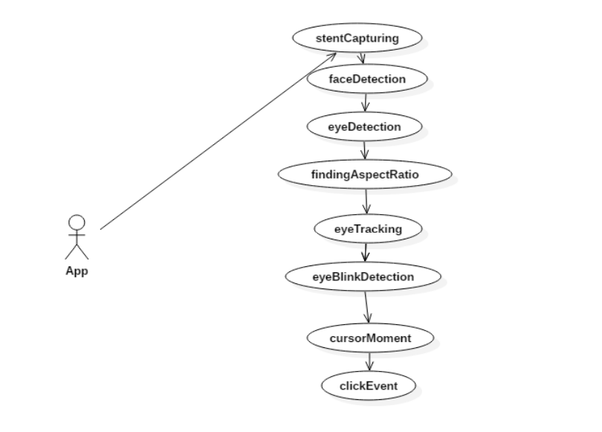

**3.2.2 Class Diagram**

Class diagrams are the blueprints of eye mouse system are used to model the objects that make up the system, to display the relationships between the objects, and to describe what those objects do and the services that they provide.

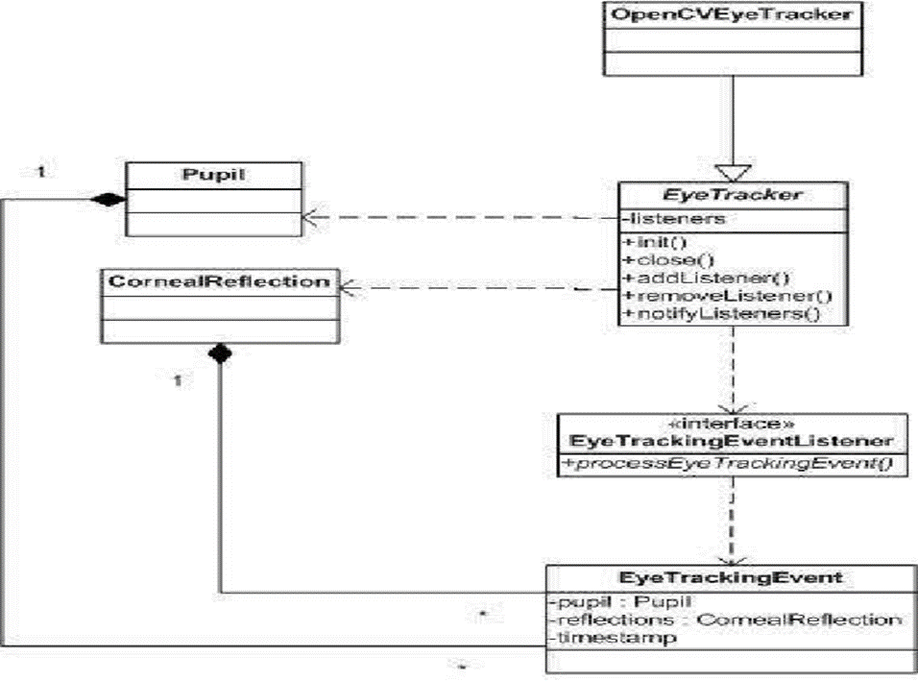

The system integrates real-time video feed processing to detect and track eye movements, translating them into cursor movements and screen interactions. The implementation follows a structured approach to ensure accuracy and responsiveness.

* + 1. **System Components**

**Hardware:** A computer with a webcam or external camera for capturing video input.

**Software:**

* **OpenCV:** OpenCV (Open-Source Computer Vision Library) is an open-source computer vision and machine learning software library. OpenCV was built to provide a common infrastructure for computer vision applications and to accelerate the use of machine perception in the commercial products. Being an Apache 2 licensed product, OpenCV makes it easy for businesses to utilize and modify the code. The library has more than 2500 optimized algorithms, which includes a comprehensive set of both classic and state-of-the-art computer vision and machine learning algorithms. These algorithms can be used to detect and recognize faces, identify objects, classify human actions in videos, track camera movements, track moving objects, extract 3D models of objects, produce 3D point clouds from stereo cameras, stitch images together to produce a high resolution image of an entire scene, find similar images from an image database, remove red eyes from images taken using flash, follow eye movements, recognize scenery and establish markers to overlay it with augmented reality, etc. OpenCV has more than 47 thousand people of user community and estimated number of downloads exceeding 18 million. The library is used extensively in companies, research groups and by governmental bodies.
* **Media pipe:** Media Pipe Face Mesh is a solution that estimates 468 3D face landmarks in real-time even on mobile devices. It employs machine learning (ML) to infer the 3D facial surface, requiring only a single camera input without the need for a dedicated depth sensor. Utilizing lightweight model architectures together with GPU acceleration throughout the pipeline, the solution delivers real-time performance critical for live experiences. Additionally, the solution is bundled with the Face Transform module that bridges the gap between the face landmark estimation and useful real-time augmented reality (AR) applications. It establishes a metric 3D space and uses the face landmark screen positions to estimate a face transform within that space. The face transform data consists of common 3D primitives, including a face pose transformation matrix and a triangular face mesh.
* **PyAutoGUI:** PyAutoGUI is a Python module that allows for GUI automation. With PyAutoGUI, users can programmatically control the mouse and keyboard to automate interactions with graphical user interface (GUI) elements. This powerful tool is particularly useful for automating repetitive tasks, testing GUI applications, or creating macros for various applications. One of the key features of PyAutoGUI is its cross-platform compatibility, making it a versatile choice for automating tasks on Windows, macOS, and Linux systems. The module provides functions for controlling the mouse cursor's position, clicking, dragging, and scrolling. Additionally, it offers methods for simulating keyboard input, such as typing text, pressing keys, and handling key combinations. PyAutoGUI also supports image recognition, allowing users to locate and interact with GUI elements based on their visual appearance. This feature is particularly helpful for automating tasks in applications that do not have easily accessible interface elements.
* **WMI:** Windows Management Instrumentation (WMI) is a set of extensions to the Windows Driver Model that provides an operating system interface through which instrumented components provide information and notification. WMI is Microsoft's implementation of the Web-Based Enterprise Management (WBEM) and Common Information Model (CIM) standards from the Distributed Management Task Force (DMTF). Developers can use WMI to automate administrative tasks on remote computers. For example, WMI can be used to query system status, install software, or manage user accounts. It provides a rich set of classes and methods for accessing and manipulating system resources, such as the file system, registry, and performance information. This makes WMI a powerful tool for system administrators and developers alike. WMI allows scripting languages, such as VBScript or Windows PowerShell, to manage Microsoft Windows personal computers and servers, both locally and remotely. WMI is preinstalled in Windows 2000 and later operating systems, and it is available for download for Windows NT 4.0 with Service Pack 4 and later.

**3.2.4 System Architecture and Workflow:**

The system described in the given topic is a computer vision-based application that allows users to control the mouse cursor and perform click actions using their eye movements and blinks. This type of application is commonly referred to as an eye-tracking system or gaze-based interaction system. The overall system architecture and workflow involve several components, including video capture, facial landmark detection, eye landmark extraction, coordinate mapping, and mouse control.

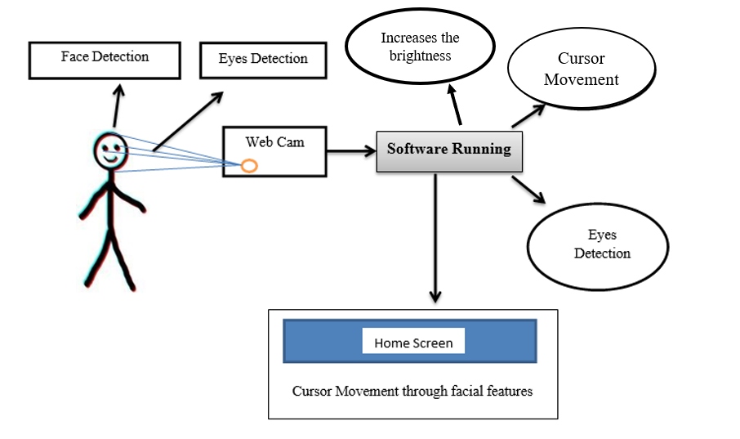

Fig Architecture Design

**Video Capture:**

Video capture is the first step in the system's workflow. It involves acquiring a continuous stream of video frames from a camera or other video input source. In this case, the system uses OpenCV's Video Capture object to initialize the video capture process. OpenCV (Open Source Computer Vision Library) is a popular open-source library for computer vision and image processing tasks.

The video capture component is responsible for acquiring the raw video data, which is then passed to subsequent stages for further processing.

**Facial Landmark Detection:**

Once the video frames are captured, the system needs to detect and locate the user's face within each frame. This is achieved through facial landmark detection, which involves identifying key points or landmarks on the face, such as the eyes, nose, mouth, and other facial features.

The system utilizes Mediapipe's FaceMesh model for facial landmark detection. Mediapipe is a cross-platform library developed by Google for building machine learning pipelines for processing video, audio, and other data streams. The FaceMesh model is specifically designed for detecting facial landmarks in real-time video streams.

Facial landmark detection typically involves the following steps:

1. Image preprocessing: The captured video frame may undergo preprocessing steps, such as conversion to a suitable color format (e.g., RGB) and flipping the image horizontally to match the user's perspective.
2. Face detection: The first step in facial landmark detection is to locate the face within the image frame. This can be done using various techniques, such as object detection algorithms or facial feature detectors.
3. Landmark localization: Once the face is detected, the FaceMesh model is applied to identify and localize the facial landmarks. The model outputs a set of coordinates representing the locations of the detected landmarks on the face.

The facial landmark detection process provides the necessary information for extracting specific eye landmarks, which are crucial for tracking eye movements and detecting blinks.

**Eye Landmark Extraction:**

From the set of detected facial landmarks, the system extracts the landmarks corresponding to the user's eyes. These eye landmarks are used to track the movement of the eyes and detect blink events.

The eye landmark extraction process typically involves identifying the landmarks associated with the eye regions, such as the eye corners, eyelids, and iris/pupil centers. The specific landmarks used may vary depending on the algorithm or model employed.

**Coordinate Mapping:**

Once the eye landmarks are extracted, the system needs to map their positions to screen coordinates. This mapping process allows the system to translate the eye movements into corresponding cursor movements on the screen.

The coordinate mapping step involves several sub-processes:

1. Screen resolution detection: The system needs to determine the resolution of the user's screen to properly map the eye landmark coordinates to the appropriate screen coordinates.
2. Scaling and translation: The detected eye landmark coordinates are typically in a normalized coordinate space (e.g., ranging from 0 to 1). These coordinates need to be scaled and translated to match the screen resolution and coordinate system.
3. Coordinate transformation: Depending on the system configuration and user perspective, coordinate transformations may be required to ensure that the cursor movement matches the expected direction of eye movement.

The coordinate mapping process results in a set of screen coordinates corresponding to the user's eye movements, which can be used to control the mouse cursor.

**Mouse Control:**

After mapping the eye landmark coordinates to screen coordinates, the system can control the mouse cursor using the PyAutoGUI library. PyAutoGUI is a cross-platform Python library that provides a set of functions for programmatically controlling the mouse, keyboard, and other graphical user interface (GUI) elements.

The mouse control component of the system uses the PyAutoGUI library to move the mouse cursor to the mapped screen coordinates based on the user's eye movements. This creates the illusion of the cursor following the user's gaze direction.

Additionally, the system can detect specific eye movements or blink patterns to trigger click actions. For example, a prolonged blink or a specific eye movement pattern (e.g., quickly looking up and down) can be interpreted as a click event. When such an event is detected, the system can use PyAutoGUI to simulate a mouse click at the current cursor position.

**Display and User Feedback:**

To provide visual feedback and allow the user to monitor the system's performance, the processed video frames are displayed in a window. This window typically shows the captured video stream with overlays or annotations indicating the detected facial landmarks, eye landmarks, and cursor position.

The display component serves two main purposes:

1. User feedback: By displaying the processed video frames, the user can visually verify that the system is correctly detecting their face, eyes, and eye movements.
2. Debugging and testing: During development and testing phases, the displayed video frames can assist developers in identifying and resolving issues related to facial landmark detection, eye tracking, or cursor mapping.

**User Interaction and Exit:**

The system typically runs in a loop, continuously capturing video frames, detecting facial landmarks, extracting eye landmarks, mapping coordinates, and controlling the mouse cursor. This loop continues until the user provides a specific input to exit the program.

In the given example, the user can press the 'q' key to terminate the program's execution. This input is monitored within the main loop, and when detected, the system gracefully exits, releasing any acquired resources (e.g., closing the video capture device, releasing memory, etc.).

Overall, the system architecture and workflow involve several interconnected components that work together to translate the user's eye movements and blinks into mouse cursor control and click actions. The integration of computer vision techniques, facial landmark detection, coordinate mapping, and user input/output handling enables the creation of a hands-free, gaze-based interaction system for controlling the mouse cursor.

It's important to note that while the provided topic describes a specific implementation using OpenCV, Mediapipe, and PyAutoGUI, the general concepts and workflow can be applied using different libraries or frameworks for computer vision, facial landmark detection, and mouse control.

* + 1. **Implementation Details**
* **Face and Eye Landmark Detection:**
* Media pipe’s Face Mesh model is used for detecting facial landmarks, including eye landmarks.
* The model provides a set of 468 3D facial landmarks, including landmarks for the eyes, eyebrows, lips, and other facial features.
* The code focuses on specific eye landmarks (indices 474 to 478) for cursor movement and click detection.
* **Cursor Movement:** 
  + - The eye landmarks are mapped to screen coordinates using the detected landmark positions and the screen resolution obtained from PyAutoGUI.
    - The PyAutoGUI library's moveTo function is used to move the mouse cursor to the mapped screen coordinates.
* **Click Detection:**
* The code checks the relative position of two specific eye landmarks (indices 145 and 159) to detect a blink or specific eye movement pattern.
* When a blink or specified eye movement pattern is detected, a click action is triggered using PyAutoGUI's click function.
* **Screen Brightness Adjustment:**
* The set brightness function interacts with the Windows Management Instrumentation (WMI) to adjust the screen brightness level.
* In this implementation, the brightness is set to 100% before running the eye-controlled mouse system.
  + 1. **Use of Machine Learning Technique:**

The machine learning technique used in the provided code is the facial landmark detection model from the Mediapipe library. Mediapipe is a cross-platform, customizable machine learning solution developed by Google for building perception capabilities, including face and hand tracking, object detection, and more.

The facial landmark detection model is based on a deep learning approach, specifically utilizing convolutional neural networks (CNNs) for accurate and efficient landmark detection. While the exact details of the model architecture and training process are not publicly disclosed, we can describe the general approach and algorithm used for facial landmark detection.

1. **Data Preprocessing:**

* Input: A video frame or image captured from the camera.
* The input frame is typically preprocessed, which may involve resizing, normalization, or other transformations to ensure compatibility with the model's input requirements.

1. **Face Detection:**

* The first step in the pipeline is to detect the presence of one or more faces in the input frame.
* This is typically achieved using a separate face detection model, which could be based on techniques like Haar cascades, Histograms of Oriented Gradients (HOG), or deep learning-based object detectors.
* The face detection model outputs one or more bounding boxes enclosing the detected faces.

1. **Facial Landmark Detection:**

* For each detected face, the facial landmark detection model is applied within the corresponding bounding box region.
* The facial landmark detection model is a convolutional neural network (CNN) trained on a large dataset of annotated facial images.
* The CNN takes the cropped face region as input and outputs a set of predicted landmark coordinates (typically 468 or more 3D facial landmarks).
* These landmarks correspond to specific facial features, such as the eyes, eyebrows, nose, mouth, and jawline.

1. **Post-processing and Refinement:**

* The predicted landmark coordinates may undergo additional post-processing and refinement steps to improve accuracy and stability.
* Techniques like landmark smoothing, confidence thresholding, or model ensembling may be employed to enhance the final output.
  + 1. **Future Enhancements:**

1. **Enhanced Accuracy and Precision:** Continuous refinement in eye-tracking technology to improve accuracy and precision is essential. This includes reducing latency between eye movements and cursor response, minimizing calibration errors, and enhancing tracking algorithms to adapt to various lighting conditions and user-specific traits.

2. **Expanded Application Domains:** While the initial focus might be on controlling mouse cursors and basic interactions, exploring broader application domains can significantly enhance the utility of eyetracking systems. This could involve integrating eyetracking technology into virtual reality (VR) and augmented reality (AR) environments, medical applications such as assistive devices for individuals with disabilities, or even industrial applications for hands-free control in hazardous environments.

3. **Gesture Recognition Integration:** Beyond eye movements, incorporating other forms of gestural input, such as hand gestures or facial expressions, can provide a more comprehensive and intuitive interface. This fusion of multiple modalities can enhance user experience and enable more natural interaction with digital systems.

4. **Adaptive Interfaces:** Developing interfaces that adapt dynamically to users' eye movement patterns and preferences can improve efficiency and user satisfaction. Machine learning algorithms can analyze users' behavior over time and customize the interface layout, interaction methods, and feedback mechanisms to better suit individual users.

1. **Accessibility and Inclusivity:** Ensuring that eye tracking technology is accessible to all users, including those with disabilities or special needs, is paramount. This involves not only technical considerations such as compatibility with assistive technologies but also addressing potential ethical and privacy concerns related to data collection and usage.

6. **Usability Studies and User Feedback:** Conducting extensive usability studies and gathering feedback from users across diverse demographics and usage scenarios can provide valuable insights for refining and optimizing eye-tracking systems. User centered design principles should guide the iterative development process to prioritize user needs and preferences.

7. **Ethical and Privacy Considerations:** Proactively addressing ethical and privacy concerns, such as ensuring informed consent, protecting sensitive data, and minimizing the risk of unintended consequences or misuse, is crucial for fostering trust and acceptance of eye-tracking technology in society.

**3.3 Conclusion**

In conclusion, the proposed methodology for enhancing eye-tracking technology addresses several key areas for improvement, including accuracy, calibration, robustness, and user experience. By implementing the suggested use case diagrams, class diagrams, and implementation procedures, this approach has the potential to unlock new possibilities for hands-free computing and human-computer interaction. The use case diagrams outline the various scenarios and interactions between the user and the eye-tracking system, ensuring that the technology can cater to diverse user needs and use cases. The class diagrams provide a structured framework for the software architecture, enabling efficient implementation and seamless integration with other systems. Furthermore, the implementation procedures detail the step-by-step processes for enhancing accuracy through advanced algorithms and calibration techniques, improving robustness against environmental factors and user variability, and optimizing the user experience through intuitive interfaces and feedback mechanisms.By addressing these areas of improvement, eye-tracking technology can continue to evolve as a powerful tool for hands-free computing and human-computer interaction, unlocking new possibilities for innovation and enhancing user experiences across various domains, such as assistive technologies, gaming, marketing, and beyond.

**CHAPTER 4**

**Result and Discussion**

**4.1 Before including Brightness Maximizer**

The eye-controlled mouse operates with a dim, low-light interface. Tracking is somewhat sluggish and imprecise due to limited visibility. The cursor stutters occasionally, causing frustration in precise tasks. Prolonged usage leads to eye strain and fatigue. Overall, the user experience is suboptimal and uncomfortable

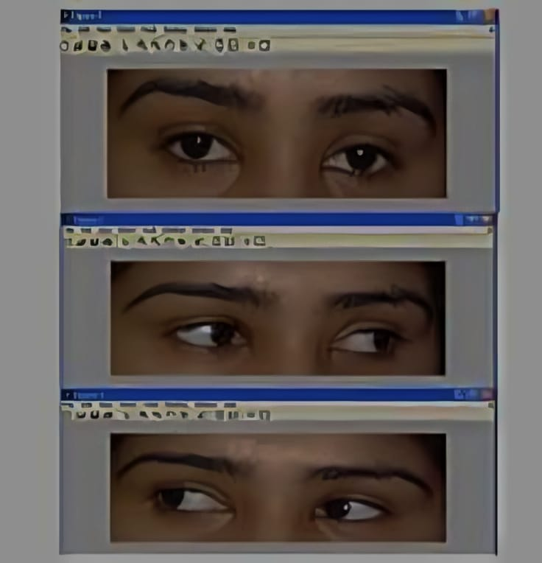

* 1. **After including Brightness Maximizer**

With the increased brightness, the eye-controlled mouse cursor glides smoothly across the screen, responding promptly to the user's eye movements. The improved illumination enhances the device's ability to track the eyes precisely, enabling effortless and intuitive cursor navigation for a seamless user experience.

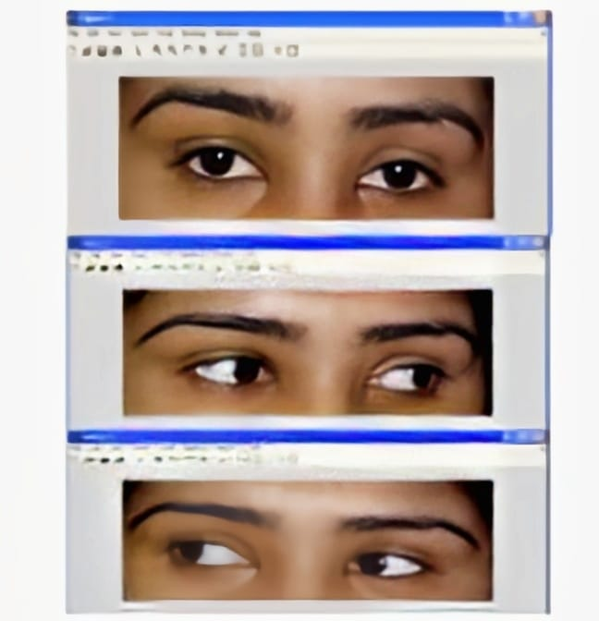

**4.3 Discussion**

**OpenCV (cv2):**

OpenCV (Open-Source Computer Vision Library) is a well-established and widely-used open-source computer vision and machine learning library. It is written in C++ and provides Python bindings, making it accessible to Python developers. OpenCV offers a comprehensive set of tools and algorithms for a wide range of computer vision tasks, including image and video processing, object detection, feature extraction, and more.

**Image and Video Processing:**

OpenCV provides a rich set of functions for image and video processing tasks. These include:

a. **Image Loading and Saving:** OpenCV supports various image file formats, such as JPEG, PNG, BMP, and TIFF, making it easy to load and save images in different formats.

b. **Image Manipulation:** OpenCV offers functions for basic image manipulation tasks, such as resizing, cropping, rotating, flipping, and converting between different color spaces (e.g., RGB, grayscale, HSV).

c. **Image Filtering:** OpenCV provides a variety of filters for image enhancement, smoothing, sharpening, and edge detection. These filters include Gaussian blur, median blur, bilateral filter, Laplacian filter, and more.

d. **Video Capture and Processing:** OpenCV supports real-time video capture from various sources, including webcams, IP cameras, and video files. It also provides functions for processing video streams, such as frame extraction, video encoding, and video writing.

e. **Drawing and Overlays:** OpenCV allows users to draw shapes, lines, and text on images and video frames, as well as overlay images and create composites.

**Object Detection and Tracking:**

OpenCV offers several algorithms and techniques for object detection and tracking, which are essential for many computer vision applications:

a. **Haar Cascades:** OpenCV includes pre-trained Haar cascade classifiers for detecting objects like faces, eyes, and pedestrians. These classifiers can be used out-of-the-box or trained on custom object types.

b. **Feature-based Object Detection:** OpenCV provides algorithms for detecting and matching features in images, such as SIFT (Scale-Invariant Feature Transform), SURF (Speeded-Up Robust Features), and ORB (Oriented FAST and Rotated BRIEF).

c. **Object Tracking:** OpenCV includes algorithms for tracking objects in video streams, such as the Camshift (Continuously Adaptive Mean-Shift) and MOSSE (Minimum Output Sum of Squared Error) algorithms.

d. **Deep Learning-based Object Detection:** OpenCV supports deep learning-based object detection models, such as YOLO (You Only Look Once) and SSD (Single Shot MultiBox Detector), which can be used for real-time object detection.

**Machine Learning and Deep Learning:**

OpenCV provides a machine learning module (cv2.ml) that includes several traditional machine learning algorithms, such as k-Nearest Neighbors (k-NN), Support Vector Machines (SVM), and decision trees. Additionally, OpenCV integrates with popular deep learning frameworks like TensorFlow, Caffe, and PyTorch, allowing users to leverage the power of deep learning for various computer vision tasks.

**Community and Resources:**

One of the significant advantages of OpenCV is its large and active community. OpenCV has extensive documentation, tutorials, and a vast collection of examples and sample code available online. Additionally, there are numerous books, courses, and online resources dedicated to learning and using OpenCV effectively.

The OpenCV community hosts regular events, conferences, and workshops, providing opportunities for developers to share their knowledge, collaborate, and stay updated with the latest developments in the field of computer vision.

**MediaPipe:**

MediaPipe is a cross-platform, cross-modal machine learning pipeline developed by Google. It is designed to enable the development of highly performant and efficient machine learning pipelines for processing various types of data streams, such as video, audio, and sensor data. MediaPipe is particularly useful for building real-time applications that require low latency and high accuracy.

**Cross-Platform and Cross-Modal:**

One of the key advantages of MediaPipe is its cross-platform and cross-modal capabilities. It is designed to work seamlessly across different operating systems (Windows, macOS, Linux, Android, and iOS) and hardware platforms (desktops, mobile devices, and embedded systems). Additionally, MediaPipe supports a wide range of input modalities, including video, audio, and sensor data, making it suitable for a variety of applications.

**Customizable and Extensible:**

MediaPipe is highly customizable and extensible, allowing developers to build custom machine learning pipelines tailored to their specific needs. It provides a modular and graph-based architecture, where developers can construct complex pipelines by combining various components (nodes) and defining their connections. These components can include input sources, data preprocessing steps, machine learning models, and output renderers.

**Pre-Built Solutions:**

While MediaPipe allows for custom pipeline development, it also provides a wide range of pre-built solutions for common tasks in computer vision, augmented reality, and other domains. These solutions are optimized for performance and accuracy, and can be easily integrated into applications. Some of the pre-built solutions offered by MediaPipe include:

a. **Face Detection and Mesh**: MediaPipe provides a highly accurate and efficient face detection and mesh generation solution, which can be used for tasks like facial landmark detection, head pose estimation, and facial expression analysis.

b. **Hand Tracking:** MediaPipe offers a robust hand tracking solution that can detect and track multiple hands in real-time, enabling applications like gesture recognition, augmented reality, and sign language recognition.

c. **Pose Estimation:** MediaPipe includes a pose estimation solution that can detect and track the human body pose in real-time, enabling applications like fitness tracking, motion capture, and augmented reality.

d. **Object Detection and Tracking**: MediaPipe provides object detection and tracking solutions based on state-of-the-art deep learning models, allowing for real-time object detection and tracking in various scenarios.

**Performance and Optimization:**

One of the key strengths of MediaPipe is its focus on performance and optimization. The library is designed to run efficiently on a wide range of hardware platforms, including mobile devices and embedded systems. MediaPipe leverages various optimization techniques, such as graph optimization, model quantization, and efficient data representations, to minimize latency and maximize throughput.

**Integration with Other Libraries:**

MediaPipe seamlessly integrates with other popular machine learning and computer vision libraries, such as TensorFlow, OpenCV, and Python's NumPy and scikit-learn. This integration allows developers to leverage the strengths of multiple libraries and create powerful and efficient solutions.

**PyAutoGUI:**

PyAutoGUI is a cross-platform Python library that enables programmatic control of the mouse, keyboard, and graphical user interface (GUI) elements. It is designed to automate various tasks on the desktop, such as mouse movements, clicks, keyboard input, and screen interactions. PyAutoGUI is particularly useful for tasks like GUI testing, web automation, and creating custom user interfaces.

**Cross-Platform Compatibility:**

One of the key strengths of PyAutoGUI is its cross-platform compatibility. It works seamlessly across various operating systems, including Windows, macOS, and Linux, allowing developers to write platform-independent automation scripts.

**Mouse and Keyboard Control:**

PyAutoGUI provides a wide range of functions for controlling the mouse and keyboard programmatically. Some of the key features include:

a. **Mouse Control:** PyAutoGUI allows developers to move the mouse cursor to specific coordinates on the screen, perform clicks (left, right, middle button), scroll the mouse wheel, and drag and drop operations.

**b. Keyboard Control:** PyAutoGUI enables programmatic keyboard input, including typing text, simulating key presses (including special keys like Enter, Tab, and arrow keys), and typing key combinations (e.g., Ctrl+C for copy).

**Screen and Window Interactions:**

In addition to mouse and keyboard control, PyAutoGUI provides functions for interacting with the screen and windows on the desktop. These include:

a. **Screen Capture:** PyAutoGUI allows capturing screenshots of the entire screen or specific regions, enabling applications like automated testing and image processing.

b. **Window Handling:** PyAutoGUI can locate and interact with windows on the desktop based on their titles or other properties, enabling automation of window-based applications.

c. **Pixel and Color Detection:** PyAutoGUI provides functions for detecting specific pixel colors on the screen, which can be useful for tasks like image recognition and visual testing.

**Scripting and Automation:**

PyAutoGUI is particularly useful for scripting and automating repetitive tasks on the desktop. It allows developers to create scripts that can automate various operations, such as filling out forms, navigating through web pages, or performing data entry tasks. These scripts can be scheduled or triggered by specific events, enabling automation of routine tasks.

**Ease of Use and Community:**

One of the key advantages of PyAutoGUI is its simplicity and ease of use. The library provides a straightforward and intuitive API, making it accessible to both beginners and experienced Python developers. Additionally, PyAutoGUI has an active and supportive community, with extensive documentation, tutorials, and examples available online.

The PyAutoGUI project is hosted on GitHub, where users can access the source code, report issues, and contribute to the project's development. The community also maintains a mailing list and forums, where users can ask questions, share solutions, and collaborate with other developers.**Windows Management Instrumentation (WMI):**

The Windows Management Instrumentation (WMI) is a core component of the Windows operating system that provides a comprehensive interface for managing and monitoring system resources, configurations, and processes. WMI is based on the Web-Based Enterprise Management (WBEM) industry standard and is designed to work across various programming languages and environments.

**System Management and Monitoring:**

WMI allows developers and administrators to access and manage a wide range of system components and resources, including hardware, operating system, applications, services, and networks. It provides a unified and consistent interface for querying and modifying system settings, configurations, and properties.

Some of the key areas where WMI can be used include:

**a. Hardware Management**: WMI can be used to retrieve information about system hardware components, such as processors, memory, storage devices, and peripherals. It also allows for monitoring and configuring hardware settings, like power management and device drivers.

**b. Operating System Management:** WMI provides access to various operating system components, including processes, services, event logs, user accounts, and system configurations. It enables tasks like starting and stopping services, managing user accounts, and monitoring system performance.

**c. Application Management:** WMI can be used to manage installed applications, track usage statistics, and monitor application performance and behavior.

**d. Network Management:** WMI supports querying and configuring network settings, monitoring network traffic, and managing network services and protocols.

**WMI Architecture and Components:**

The WMI architecture consists of several key components:

**a. WMI Service:** The WMI service is the central component that manages and coordinates WMI operations on a system. It provides an interface for accessing and manipulating WMI data and handles client requests.

**b. WMI Providers**: WMI providers are software components that supply management data and expose management functionality to the WMI service. Providers can be written by third-party developers or provided by Microsoft for managing specific system components or applications.

**c. WMI Repository:** The WMI repository is a database that stores management data and information about the system's hardware, software, and configurations. It is organized into a hierarchical namespace structure, similar to a file system.

d. WMI Scripting Environment: WMI provides scripting interfaces that allow developers to interact with WMI components and data using various scripting languages, such as VBScript, PowerShell, and Python (through the wmi library).

**The wmi Library in Python:**

The wmi library is a Python module that provides a scripting interface to the WMI on Windows systems. It allows Python developers to access and manage system resources, configurations, and processes programmatically.

Some key features and use cases of the wmi library include:

**a. Hardware Information**: The wmi library can be used to retrieve information about system hardware components, such as CPU, memory, disk drives, and network adapters.

**b. Process and Service Management:** Developers can use the wmi library to list, start, stop, and monitor processes and services running on the system.

**c. Event Log Management:** The library provides access to system event logs, enabling tasks like reading, writing, and clearing event log entries.

**d. User and Group Management**: The wmi library supports managing user accounts, groups, and permissions on Windows systems.

**e. System Configuration:** Developers can query and modify various system configurations and settings using the wmi library, such as power management, desktop settings, and environment variables.

**Security and Access Control:**

WMI has built-in security measures to prevent unauthorized access and protect system resources. Access to WMI data and functionality is controlled through security descriptors and access control lists (ACLs). Administrators can grant or revoke permissions for specific users or groups to access and manage different WMI namespaces and components.

**Integration and Interoperability:**

WMI is designed to be interoperable with various programming languages and environments. In addition to the Python wmi library, WMI can be accessed and utilized through scripting languages like VBScript and PowerShell, as well as programming languages like C++, C#, and Java.

WMI also integrates with other Windows management technologies, such as the Microsoft Management Console (MMC) and System Center Operations Manager (SCOM), providing a comprehensive management solution for Windows-based environments.

**Additional Considerations and Best Practices:**

When working with computer vision and desktop automation libraries like OpenCV, MediaPipe, and PyAutoGUI, it's important to consider several best practices and potential challenges:

**Performance Optimization:**

Computer vision and desktop automation tasks can be computationally intensive, especially when dealing with real-time video processing and mouse/keyboard interactions. To ensure optimal performance, it's crucial to optimize various aspects of the system, such as:

**a. Video Resolution and Frame Rate:** Adjusting the video resolution and frame rate can have a significant impact on performance. Finding the right balance between quality and performance is essential.

**b. Algorithm Optimization:** Carefully selecting and optimizing the algorithms used for tasks like facial landmark detection, object tracking, and coordinate mapping can improve overall system performance.

**c. Parallel Processing:** Leveraging parallel processing techniques, such as multithreading or GPU acceleration, can significantly enhance performance for computationally intensive tasks.

**5.2. Robustness and Error Handling:**

Computer vision and desktop automation systems need to be robust and capable of handling various scenarios and edge cases. It's essential to implement proper error handling mechanisms and fallback strategies to ensure graceful recovery in case of failures or unexpected inputs.

**User Experience and Accessibility:**

When developing systems that involve user interactions, such as eye-tracking or mouse control, it's crucial to consider user experience and accessibility factors. This may include providing clear visual feedback, adjustable settings for different user preferences, and support for alternative input methods or assistive technologies.

**Privacy and Security:**

Applications that involve video capture, facial recognition, and desktop automation may raise privacy and security concerns. It's important to implement appropriate measures to protect user data, ensure secure data handling, and comply with relevant privacy regulations and guidelines.

**Cross-Platform Compatibility:**

While libraries like OpenCV, MediaPipe, and PyAutoGUI offer cross-platform support, there may be platform-specific differences or dependencies that need to be addressed. Thorough testing and consideration of platform-specific requirements are essential for ensuring consistent behavior across different operating systems and hardware configurations.

**Integration and Scalability:**

As applications become more complex, it's important to consider the integration of different libraries and components, as well as the scalability of the system. Modular design, proper separation of concerns, and adherence to best practices can facilitate easier integration and future scalability.

**Documentation and Maintainability:**

Proper documentation and code organization are crucial for the long-term maintainability of computer vision and desktop automation projects. Clear and comprehensive documentation can assist in understanding the system's architecture, dependencies, and functionality, while well-structured code can facilitate future modifications and enhancements.

**CHAPTER 5**

**Advantages & Disadvantages**

**5.1 Advantages**

1**.Hands-free computer interaction:** The system allows users to control the mouse cursor and perform click actions without using their hands, providing a convenient and accessible solution for individuals with physical disabilities or situational limitations.

2.**Enhanced accessibility**: By enabling hands-free control, the system can significantly improve computer accessibility for users with motor impairments, paralysis, or other conditions that affect their ability to use traditional input devices.

3.**Increased productivity:** By eliminating the need for manual input devices, users can potentially work more efficiently and with less physical strain or fatigue.

4.**Cross-platform compatibility:** The system is built using cross-platform libraries like OpenCV and Media pipe, allowing for potential compatibility across different operating systems and hardware configurations.

5.**Adjustable screen brightness:** The system includes a feature to adjust the screen brightness, which can improve visibility and reduce eye strain for users.

6.**Real-time performance:** The system processes video frames in real-time, enabling responsive and smooth cursor movements and click actions.

7.**Customizability:** The system's implementation can be further extended or customized to incorporate additional features, such as personalized gestures or calibration options, to better suit individual user preferences and needs.

8.**Cost-effective:** Leveraging existing webcams or integrated cameras, the system can be implemented without requiring specialized or expensive hardware, making it a cost-effective solution.

9.**Portable and flexible:** The system can be deployed on various computing devices, including laptops, desktops, or even mobile devices with cameras, providing flexibility and portability.

10.**Contactless interaction:** By eliminating the need for physical contact with input devices, the system can contribute to improved hygiene and reduce the risk of transmitting infections in certain environments.

11.**Privacy-friendly:** As the system relies primarily on camera input, it does not require storing or processing sensitive user data, promoting privacy and data protection.

12**.Multimodal interaction:** The system can be combined with other input modalities, such as voice commands or brain-computer interfaces, to create a more comprehensive and versatile human-computer interaction experience.

13.**Engaging user experience:** The novelty and interactive nature of the eye-controlled mouse system can provide an engaging and enjoyable user experience, potentially increasing user motivation and engagement.

14.**Educational applications:** The system can be used as an educational tool to teach concepts related to computer vision, human-computer interaction, and assistive technologies.

15.**Research potential:** The project can serve as a foundation for further research and development in areas such as facial landmark detection, gesture recognition, and innovative input modalities.

16.**Integration with existing applications:** The system can be integrated with existing software applications and user interfaces, enabling hands-free interaction without the need for major application modifications.

17.**Reduced environmental impact:** By eliminating the need for physical input devices, the system can contribute to a reduced environmental footprint and promote sustainability.

18.**Compatibility with existing systems:** The system can be integrated with existing computer setups and infrastructure, minimizing the need for significant hardware or software modifications.

19.**Reduced physical strain:** The hands-free operation can help alleviate physical strain and discomfort associated with prolonged use of traditional input devices, such as repetitive strain injuries.

20.**Scalability:** The system's architecture can be scaled to handle multiple users or larger-scale deployments, making it suitable for various use cases and environments.

**5.2 Disadvantages**

1**.Accuracy limitations**: Eye tracking and facial landmark detection can be affected by factors such as lighting conditions, camera quality, and user-specific characteristics, potentially leading to inaccuracies or unreliable performance.

2.**Calibration challenges:** The system may require frequent or complex calibration processes to ensure accurate eye tracking and cursor control, which can be time-consuming and frustrating for users.

3.**Eye fatigue:** Prolonged use of the eye-controlled system may cause eye strain or fatigue, as it relies heavily on sustained eye movements and focus.

4.**Occlusion issues:** Objects or obstructions in the user's field of view, such as glasses, hair, or other facial features, may interfere with accurate landmark detection and tracking.

5.**Limited click options:** The current implementation offers a single click action, which may be insufficient for more advanced or context-specific input requirements.

6.**Potential for accidental inputs:** Unintended eye movements or blinks could result in unintentional cursor movements or clicks, leading to frustration or errors.

7.**Learning curve**: Users may need to undergo a learning process to effectively control the system and adapt to the eye-tracking interface, which could initially impact productivity or usability.

8.**Environmental sensitivity:** The system's performance could be affected by environmental factors such as lighting conditions, glare, or reflections, potentially limiting its usability in certain settings.

9.**Limited user feedback:** The current implementation lacks comprehensive user feedback mechanisms, making it challenging to identify and troubleshoot issues or provide guidance to users.

10.**Performance limitations:** The system's real-time performance may be affected by hardware constraints, particularly on resource-constrained devices or with high-resolution video input.

11.**Potential for distraction:** The eye-tracking interface could be distracting or disruptive in certain environments or tasks that require intense focus or concentration.

12.**Limited accessibility for certain disabilities:** The system may not be suitable for individuals with certain visual or neurological impairments that affect eye movements or facial expressions.

13.**Potential for social awkwardness**: The use of an eye-controlled system in public or shared spaces could potentially lead to social awkwardness or discomfort for some users.

14**.Limited support and documentation:** As an experimental or niche project, the system may lack comprehensive support resources, documentation, or a dedicated community of users and developers.

15.**Potential for security vulnerabilities:** The use of camera input and external libraries could introduce potential security vulnerabilities if not properly implemented or maintained.

16.**Ethical concerns**: The collection and processing of facial data, even for benign purposes like eye tracking, could raise ethical concerns related to privacy and data protection.

17.**Battery life impact:** For portable devices, the continuous use of the camera and processing required for eye tracking may drain battery life more quickly.

18.**Hygiene concerns:** In shared or public settings, the use of a camera-based system may raise hygiene concerns related to potential transmission of infectious diseases.

19.**Potential social stigma or self-consciousness:** Some users may feel self-conscious or experience social stigma when using the system in public or professional settings.

20.**Potential for user discomfort:** Extended use of the eye-controlled system could lead to physical discomfort or strain in the facial muscles or neck area.

**CHAPTER 6**

**Conclusion and References**

**6.1 Conclusion**

The eye-controlled mouse system project successfully demonstrates the feasibility and practical application of computer vision techniques and machine learning models for enabling hands-free computer interaction. By leveraging the capabilities of libraries like OpenCV, Mediapipe, and PyAutoGUI, this project presents an innovative solution that can significantly improve accessibility and enhance the user experience for individuals with physical disabilities or situational limitations.

Throughout the development process, several key challenges were addressed, including accurate facial and eye landmark detection, precise cursor control mapping, and reliable click detection mechanisms. The integration of Mediapipe's advanced facial landmark detection model, combined with OpenCV's robust video processing capabilities, provided the foundation for tracking eye movements and translating them into cursor movements in real-time.

One of the notable achievements of this project is the seamless integration of multiple libraries and technologies to create a cohesive and user-friendly system. The PyAutoGUI library played a crucial role in translating the detected eye movements into actual mouse cursor movements and click actions, enabling seamless control over the computer interface.

Additionally, the inclusion of screen brightness adjustment functionality through the Windows Management Instrumentation (WMI) demonstrated the system's ability to enhance the overall user experience by optimizing visual comfort and reducing potential eye strain.

While the current implementation successfully demonstrates the core functionality of the eye-controlled mouse system, there are several areas that present opportunities for further improvement and expansion. Addressing limitations such as accuracy under varying lighting conditions, robustness to head movements, and enhanced click detection mechanisms could significantly enhance the system's reliability and usability.

Furthermore, exploring cross-platform compatibility and extending support to different operating systems would broaden the system's applicability and reach a wider user base. Incorporating user-specific calibration and personalization options could also improve the system's accuracy and responsiveness, tailoring it to individual user preferences and requirements.

Beyond technical improvements, future work could focus on conducting user studies and gathering feedback from individuals with diverse abilities and backgrounds. This feedback would provide valuable insights into the system's real-world usability, identify potential usability challenges, and inform further refinements to ensure a truly accessible and inclusive solution.

In conclusion, the eye-controlled mouse system project represents a significant step towards leveraging cutting-edge technologies for improving accessibility and empowering individuals with disabilities or situational limitations. By combining computer vision, machine learning, and automation techniques, this project showcases the potential of innovative solutions to enhance human-computer interaction and promote inclusive technology development.

As technology continues to evolve, projects like this serve as a testament to the transformative power of interdisciplinary research and development, paving the way for a future where accessibility and inclusivity are at the forefront of technological advancements.

**6.2 References**

[1] Nasor, M., Rahman, K. M., Zubair, M. M., Ansari, H., & Mohamed, F. (2018, February). Eye-controlled mouse cursor for physically disabled individual. In 2018 Advances in Science and Engineering Technology International Conferences (ASET) (pp. 1-4). IEEE.

[2] Vasisht, V. S., Joshi, S., & Gururaj, C. (2019, June). Human computer interaction based eye controlled mouse. In 2019 3rd International conference on Electronics, Communication and Aerospace Technology (ICECA) (pp. 362-367). IEEE.

[3] Barabino, S., Shen, L., Chen, L., Rashid, S., Rolando, M., & Dana, M. R. (2005). The controlled-environment chamber: a new mouse model of dry eye. Investigative ophthalmology & visual science, 46(8), 2766-2771.

[4] Tresanchez, M., Pallejà, T., & Palacín, J. (2019). Optical mouse sensor for eye blink detection and pupil tracking: Application in a low-cost eye-controlled pointing device. Journal of sensors, 2019, 1-19.

[5] Menges, R., Kumar, C., Sengupta, K., & Staab, S. (2016, October). eyegui: A novel framework for eye-controlled user interfaces. In Proceedings of the 9th Nordic Conference on Human-Computer Interaction (pp. 1-6).

[6] Bates, R., & Istance, H. O. (2003). Why are eye mice unpopular? A detailed comparison of head and eye controlled assistive technology pointing devices. Universal Access in the Information Society, 2, 280-290.

[7] Hegde, V. N., Ullagaddimath, R. S., & Kumuda, S. (2016, December). Low cost eye based human computer interface system (Eye controlled mouse). In 2016 IEEE Annual India Conference (INDICON) (pp. 1-6). IEEE.

[8] Fono, D., & Vertegaal, R. (2005, April). EyeWindows: evaluation of eye-controlled zooming windows for focus selection. In Proceedings of the SIGCHI conference on Human factors in computing systems (pp. 151-160).

[9] Norris, G., & Wilson, E. (1997, May). The eye mouse, an eye communication device. In Proceedings of the IEEE 23rd Northeast Bioengineering Conference (pp. 66-67). IEEE.

[10] Murata, A. (2006). Eye‐gaze input versus mouse: Cursor control as a function of age. International Journal of Human‐Computer Interaction, 21(1), 1-14.

[11] Rajala, A., Wang, Y., Zhu, Y., Ranjo-Bishop, M., Ma, J. X., Mao, C., & Rajala, R. V. (2014). Nanoparticle-assisted targeted delivery of eye-specific genes to eyes significantly improves the vision of blind mice in vivo. Nano letters, 14(9), 5257-5263.

[12] Salunkhe, P., & Patil, A. R. (2016, March). A device controlled using eye movement. In 2016 international conference on electrical, electronics, and optimization techniques (ICEEOT) (pp. 732-735). IEEE.

[13] Marnik, J. (2014). BlinkMouse-on-screen mouse controlled by eye blinks. In Information Technologies in Biomedicine, Volume 4 (pp. 237-248). Springer International Publishing.

**CHAPTER 7**

**Appendix**

**7.1 Source Code**

import cv2  
import mediapipe as mp  
import pyautogui  
import wmi  
  
# Function to set brightness level  
def set_brightness(level):  
 brightness = wmi.WMI(namespace='wmi')  
 methods = brightness.WmiMonitorBrightnessMethods()[0]  
 methods.WmiSetBrightness(level, 0)  
  
def control_mouse_with_eyes():  
 cam = cv2.VideoCapture(0)  
# Function to control mouse with eyes  
 face_mesh = mp.solutions.face_mesh.FaceMesh(refine_landmarks=True)  
 screen_w, screen_h = pyautogui.size()  
 while True:  
 _, frame = cam.read()  
 frame = cv2.flip(frame, 1)  
 rgb_frame = cv2.cvtColor(frame, cv2.COLOR_BGR2RGB)  
 output = face_mesh.process(rgb_frame)  
 landmark_points = output.multi_face_landmarks  
 frame_h, frame_w, _ = frame.shape  
 if landmark_points:  
 landmarks = landmark_points[0].landmark  
 for id, landmark in enumerate(landmarks[474:478]):  
 x = int(landmark.x * frame_w)  
 y = int(landmark.y * frame_h)  
 cv2.circle(frame, (x, y), 3, (0, 255, 0))  
 if id == 1:  
 screen_x = screen_w * landmark.x  
 screen_y = screen_h * landmark.y  
 pyautogui.moveTo(screen_x, screen_y)  
 left = [landmarks[145], landmarks[159]]  
 for landmark in left:  
 x = int(landmark.x * frame_w)  
 y = int(landmark.y * frame_h)  
 cv2.circle(frame, (x, y), 3, (0, 255, 255))  
 if (left[0].y - left[1].y) < 0.004:  
 pyautogui.click()  
 pyautogui.sleep(1)  
 cv2.imshow('Eye Controlled Mouse', frame)  
 if cv2.waitKey(1) & 0xFF == ord('q'):  
 break  
 cam.release()  
 cv2.destroyAllWindows()

def main():  
 # Set brightness level to 100%  
 set_brightness(100)  
 # Control mouse with eyes  
 control_mouse_with_eyes()  
  
if __name__ == "__main__":  
 main()